Student Performance Prediction System

Project Id: AIML-5

Name : Member1 (Kulvardhan Singh Khichi)
Class Roll Number:80
University Roll Number : 2028448
Section and Group: G and G2

Name : Member2-Shivank Mahajan
Class Roll Number:62
University Roll Number : 2028848
Section and Group: G and G2

TABLE OF CONTENTS
- Problem Description 3
  - Dataset Description 3
  - Flow diagram 4
- Modules for Project Implementation…………………..…………………………5
  - Modules Used 5
  - Platform Used 6
- Machine Learning model/ Searching Technique used 7
- Evaluation metrics used 8
- Results and Visualizations 9
- Conclusion and Future Scope 11
- References 12

- Problem Description
Design and develop an end-to-end machine learning classification system to predict
loan default using customer banking data. The project should begin with exploratory
data analysis (EDA) to understand data distributions, correlations, and patterns,
followed by comprehensive data preprocessing including data cleaning, normalization,
transformation, and dimensionality reduction using Principal Component Analysis
(PCA) to handle high-dimensional data. The system should implement Support Vector
Machine (SVM) classifiers using different kernel functions such as linear, polynomial,
and radial basis function (RBF) and K-NN. The trained models must be evaluated and
compared using standard classification performance metrics including precision, recall,
F1-score, and ROC–AUC. The project should demonstrate a complete machine learning
pipeline from raw data analysis to model evaluation, emphasizing best practices in
preprocessing, model selection, and performance assessment.

1.1 Dataset Description

The project utilizes the Default of Credit Card Clients Dataset, which contains data on default payments, demographic factors, credit data, history of payment, and bill statements of credit card clients.
- Total Records (Rows): 30,000 customer entries
- Total Features (Columns): 23 predictive features and 1 target variable (the arbitrary 'ID' column was removed during preprocessing).
- Target Variable: default payment next month (renamed to target in the code). It is a binary classification variable where 1 indicates the customer defaulted on their loan, and 0 indicates they did not default.
Feature Breakdown: The 23 independent variables are categorized into the following groups:

- Basic / Demographic Information:
  - LIMIT_BAL: Amount of the given credit (includes individual and family/supplementary credit).
  - SEX: Gender (1 = male; 2 = female).
  - EDUCATION: Educational background (1 = graduate school; 2 = university; 3 = high school; 4 = others). Note: Unmapped categories (0, 5, 6) were merged into 4 during preprocessing.
  - MARRIAGE: Marital status (1 = married; 2 = single; 3 = others). Note: Category 0 was merged into 3 during preprocessing.
  - AGE: Age of the customer in years.

- History of Past Payment:
  - PAY_0 to PAY_6: History of past monthly repayment status from September to April. The measurement scale ranges from -1 (pay duly) to 1-9 (payment delay for 1 to 9 months).

- Amount of Bill Statement:
  - BILL_AMT1 to BILL_AMT6: The amount of the bill statement (in local currency) from September to April.

- Amount of Previous Payment:
  - PAY_AMT1 to PAY_AMT6: The amount paid by the customer in the previous months from September to April.

1.2 Flow Diagram

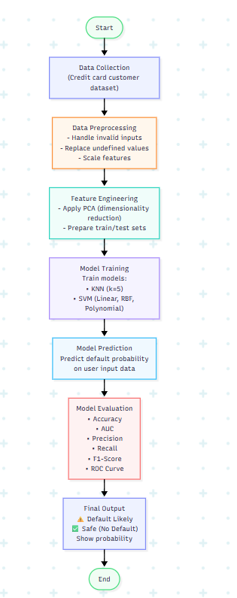
Fig.1 Sample flow diagram.

2. Modules for Project Implementation

2.1 Modules Used(mention all the inbuilt/ custom modules used and the purpose)

Explain all the inbuilt / custom modules imported and the functions used from that module. e.g.-
- Pandas – Pandas module has been used for data manipulation and analysis.
Functions used:
pd.read_csv- to read data from csv file in a pandas dataframe.

The project implementation relies on a combination of external Python libraries (inbuilt to the data science ecosystem) and custom-defined functions to handle the end-to-end pipeline from data ingestion to model prediction.

External / Inbuilt Libraries:

pandas: Used extensively for data manipulation and structuring. In Phase 3, it is used to convert the raw user input array into a 2D structured DataFrame (pd.DataFrame), allowing for easy column-based operations like replacing categorical values for EDUCATION and MARRIAGE.

numpy: Imported to support high-performance numerical and matrix operations, which run in the background of pandas and scikit-learn transformations.

scikit-learn (sklearn): The primary machine learning library used for the predictive pipeline. Specific sub-modules include:

sklearn. preprocessing.StandardScaler: Used to normalize and scale the new user input data so that it matches the exact scale and distribution of the data the model was originally trained on.

sklearn.decomposition.PCA: Used to apply Principal Component Analysis. It transforms the 23 scaled user inputs into the 15 principal components required by the trained model.

sklearn.svm.SVC: The Support Vector Classifier module. Used to load the best-performing model (SVM with RBF kernel) to execute the predict() function for the final class label (0 or 1) and predict_proba() to extract the confidence percentage.

Custom Modules / Functions:

predict_loan_default (): A custom-built Python function designed specifically for Phase 3. Its primary purposes are:

To generate an interactive Command Line Interface (CLI) that prompts the user to enter 23 specific customer banking details.

To handle potential input errors using a try-except block (ensuring only numerical values are accepted).

To encapsulate the entire inference pipeline: collecting data, applying the pandas preprocessing rules, scaling the data, applying PCA dimensionality reduction, and outputting the final user-friendly prediction and confidence score.

2.2 Platform Used: (mention all the platforms with the reason of using it)
  - Visual Studio Code: For code writing, testing, and debugging.
VS Code is equipped with multiple extensions, debugger which enhance the development experience.
  - • Jupyter Notebook: * Reason for Use: Used as the primary Interactive Development Environment (IDE) for writing, executing, and debugging the .ipynb project files. Jupyter Notebook was chosen because it allows for interactive, block-by-block code execution, which is highly beneficial for testing user inputs, visualizing data during earlier phases, and immediately viewing the output of the prediction engine.
•

3. Machine Learning Model/ Searching Technique Used(Describe each ML model/ searching technique used)

For the Phase 3 deployment, the system relies on the best-performing predictive model identified during the Phase 2 evaluation pipeline.
Support Vector Machine (SVM) with Radial Basis Function (RBF) Kernel
- Description of the Model: Support Vector Machine (SVM) is a powerful supervised machine learning algorithm used primarily for classification tasks. Its core objective is to find the optimal hyperplane in an N-dimensional space that distinctly classifies the data points into their respective categories (in this case, "Default" vs. "No Default").
- The RBF Kernel: Financial and demographic data rarely exhibit strictly linear relationships. The Radial Basis Function (RBF) kernel is a mathematical technique used within SVM to handle this non-linearity. It implicitly maps the input features into a higher-dimensional space where a linear hyperplane can successfully separate the complex classes.
- Application in Phase 3: In this final phase, the SVM (RBF) model is used strictly for inference. The model has already been trained and optimized. When the user inputs 23 new banking details via the CLI, the data is scaled and reduced to 15 dimensions using PCA. This processed array is then passed into the pre-trained SVM (RBF) model. The model calculates the data point's position relative to the established hyperplane to output:
  - A definitive class prediction (1.0 for Default, 0.0 for Safe).
  - A probability score (predict_proba) representing the model's statistical confidence in that prediction.
4. Evaluation metrics used (Describe each evaluation metric used along with formulae)

To ensure the Support Vector Machine (SVM) model deployed in Phase 3 is highly reliable, it was validated using standard classification metrics. These metrics are based on the Confusion Matrix components: True Positives (TP) (correctly predicted defaults), True Negatives (TN) (correctly predicted safe customers), False Positives (FP) (safe customers incorrectly flagged as defaults), and False Negatives (FN) (defaulters incorrectly flagged as safe).
1. Accuracy
- Description: The ratio of correctly predicted observations to the total observations. It gives an overall picture of how often the model is correct.
- Formula:
- Accuracy = \frac{TP + TN}{TP + TN + FP + FN}
2. Precision
- Description: The ratio of correctly predicted positive observations to the total predicted positive observations. In this system, it answers the question: Of all the customers the model flagged as likely to default, how many actually defaulted? High precision relates to a low false positive rate.
- Formula:Precision = \frac{TP}{TP + FP}
3. Recall (Sensitivity)
- Description: The ratio of correctly predicted positive observations to all observations in the actual class. It answers the question: Of all the customers who actually defaulted, how many did the model successfully identify Formula :Recallfrac{TP}{TP + FN}
4. F1-Score
- Description: The weighted average (harmonic mean) of Precision and Recall. Therefore, this score takes both false positives and false negatives into account. It is especially useful for uneven class distributions (which is common in financial default datasets).
- Formula:
F1\text{-}Score = 2 \times \frac{Precision \times Recall}{Precision + Recall}
5. ROC-AUC (Receiver Operating Characteristic - Area Under Curve)
- Description: ROC is a probability curve, and AUC represents the degree or measure of separability. It tells how much the model is capable of distinguishing between classes (Defaulters vs. Non-Defaulters). An excellent model has an AUC near 1.0.
6. Confidence Score (Phase 3 Output Metric)
- Description: Specifically implemented in the Phase 3 prediction script utilizing the predict_proba () function. Instead of just giving a binary 1 or 0 prediction, it calculates the statistical probability that the customer belongs to the "Default" class.
- Output: Displayed to the user as a percentage (e.g., Confidence (Probability of Default): 84.50%), providing actionable insight into the severity of the risk.

5. Results and Visualizations

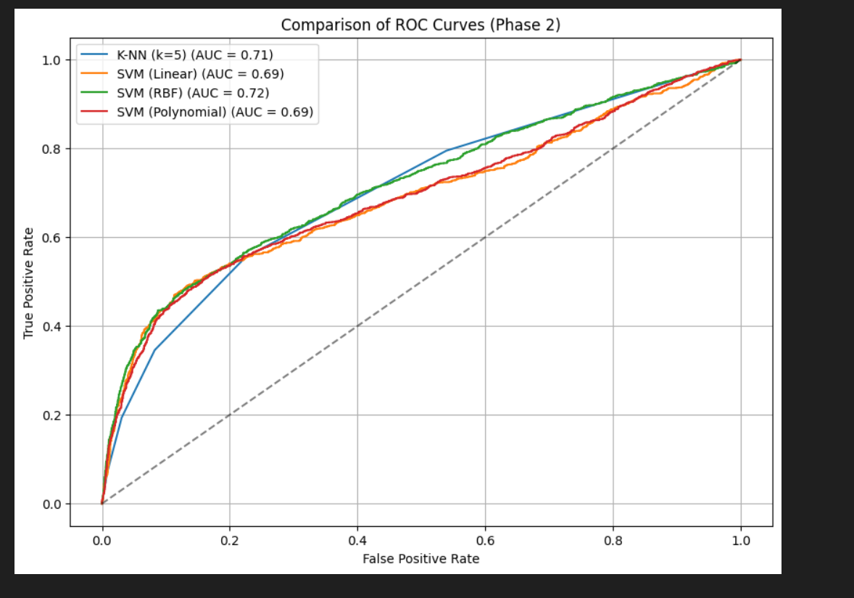

6. Conclusion and Future Scope:

Conclusion The objective of designing and developing an end-to-end machine learning classification system for predicting credit card loan defaults has been successfully achieved. Throughout the project phases, a robust pipeline was established, encompassing rigorous exploratory data analysis, data cleaning, and feature scaling. By implementing Principal Component Analysis (PCA), the system efficiently handled high-dimensional data, reducing the feature space from 23 to 15 components while retaining 95% of the variance.
After evaluating multiple classifiers (K-NN, Linear SVM, Polynomial SVM, and RBF SVM) using standard performance metrics, the Support Vector Machine with an RBF kernel was identified as the optimal model for handling the complex, non-linear relationships in the financial data. In Phase 3, this model was successfully operationalized into an interactive prediction system. The final deployed script seamlessly captures real-time customer data, applies the necessary data transformations on the fly, and generates both a definitive risk classification and a statistical confidence score. This system effectively minimizes manual effort in risk assessment and provides a reliable, data-driven foundation for banking decision-making.
3.2 Future Scope While the current Phase 3 implementation provides a highly functional command-line tool, the project can be expanded in several directions to enhance its utility and scalability:
- Graphical User Interface (GUI) & Web Deployment: Transitioning the command-line interface into a fully interactive web application using frameworks like Streamlit, Flask, or Django to improve accessibility for non-technical banking staff.
- Cloud Infrastructure Integration: Hosting the prediction system on cloud platforms such as AWS. Utilizing Amazon Web Services global infrastructure (like hosting the web app in specific Regions and securely storing incoming customer datasets in S3 buckets with proper IAM controls) would make the system highly scalable and secure for enterprise use.
- Advanced Algorithm Exploration: Experimenting with advanced ensemble learning techniques (such as XGBoost or Random Forest) and deep learning (Artificial Neural Networks) to potentially yield higher ROC-AUC scores and better recall for the minority "Default" class.
- Explainable AI (XAI): Integrating interpretability frameworks like SHAP or LIME so the system not only provides a probability score but also explains the primary factors driving that prediction (e.g., highlighting that a specific delayed payment history was the biggest contributing factor to the default warning).

7. References:
Books:
- Let Us Python – Yashavant Kanetkar

Online Resources:
  - GeeksforGeeks – https://www.geeksforgeeks.org/
  - TutorialsPoint – https://www.tutorialspoint.com/cprogramming/index.htm
  - Stack Overflow – https://stackoverflow.com
  - Leet code - https://leetcode.com/

